1

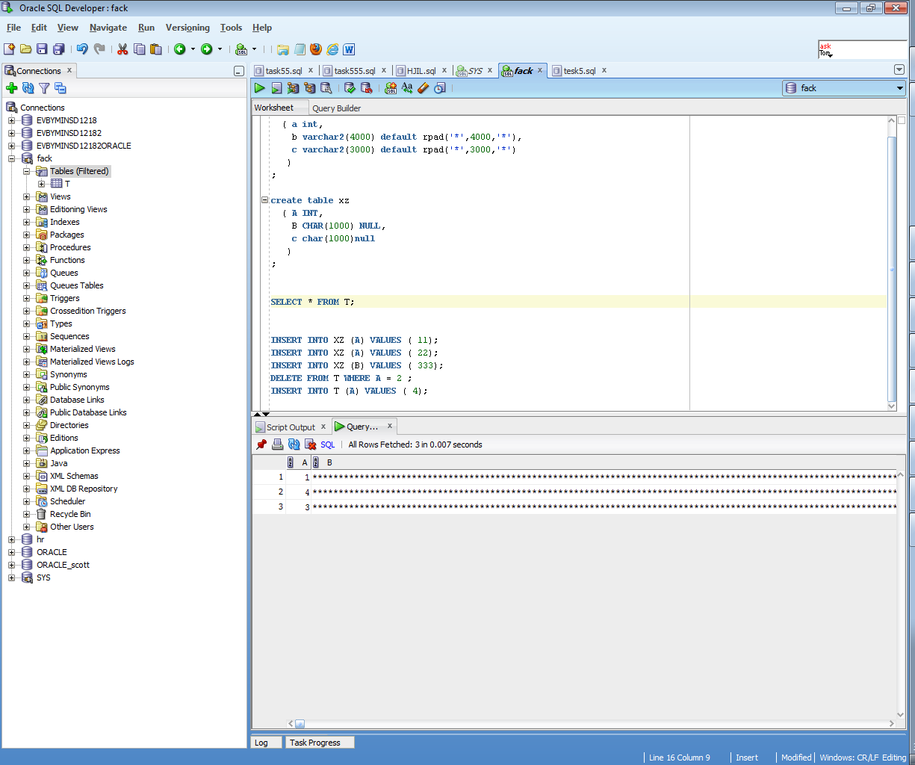

2

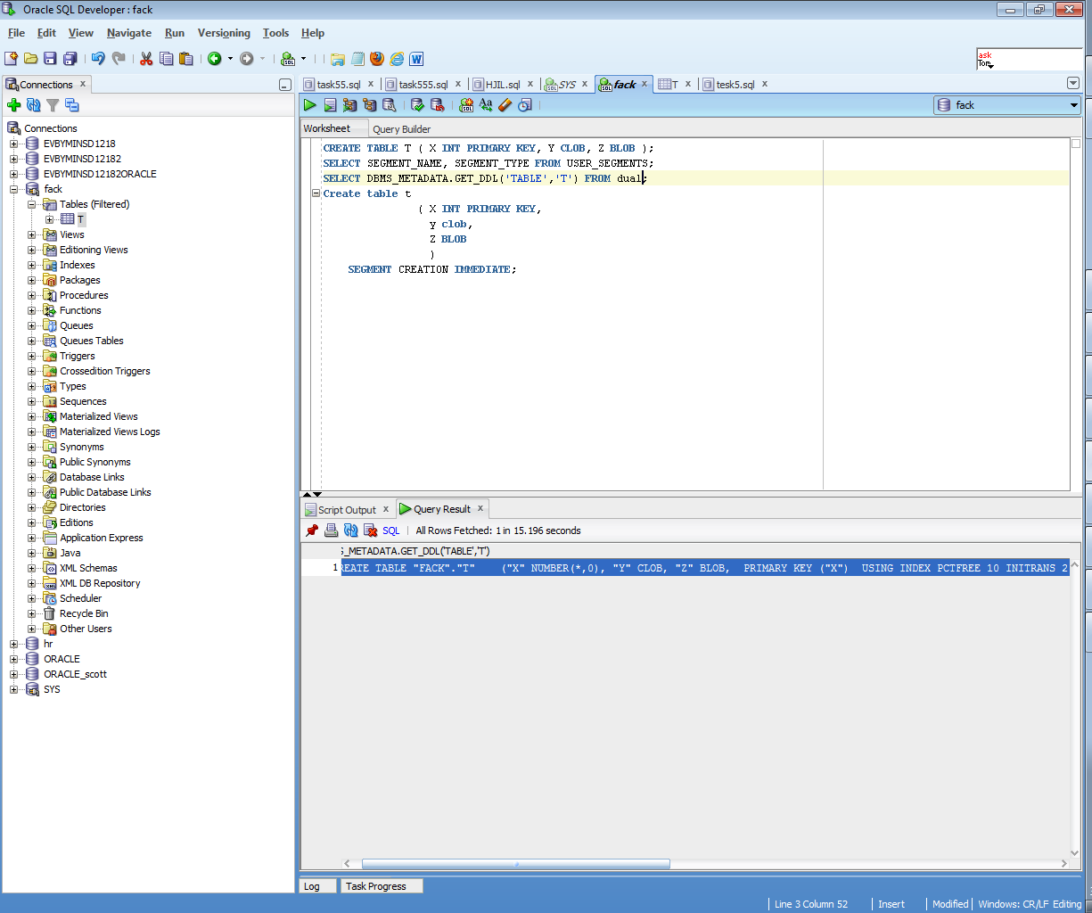

3

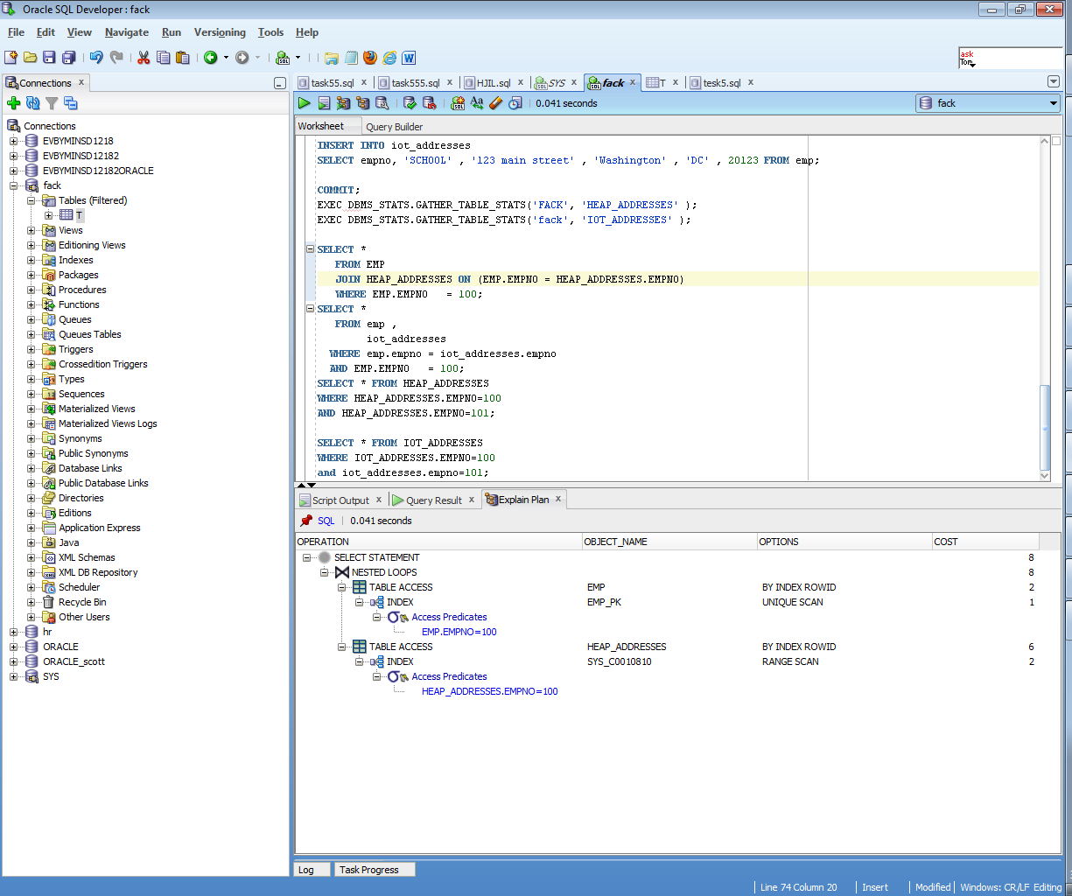

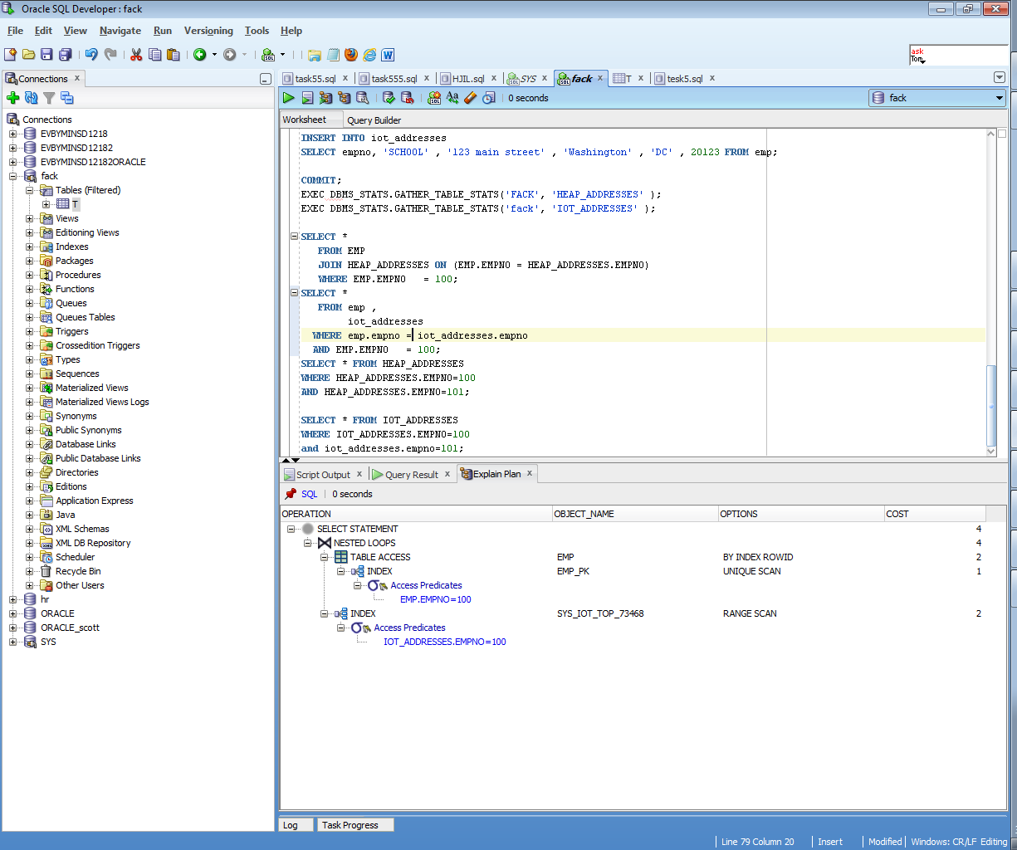

IOP is faster because:

* Heap need to compare id from heap table where index is 100 and IOP just go the way by index strait to part of table.
* But the situation may change coordinately if we will use strait read (select *…), or tray to find information not by PK.

So, I understand that IOP would better only if we use only PK.

4

In first picture we see that there is data in table dept and there is no data in table epm where dept.deptno=40,41,42,44. If we will put data into emp table, it would be written in block according the emp_dept_cluster index.

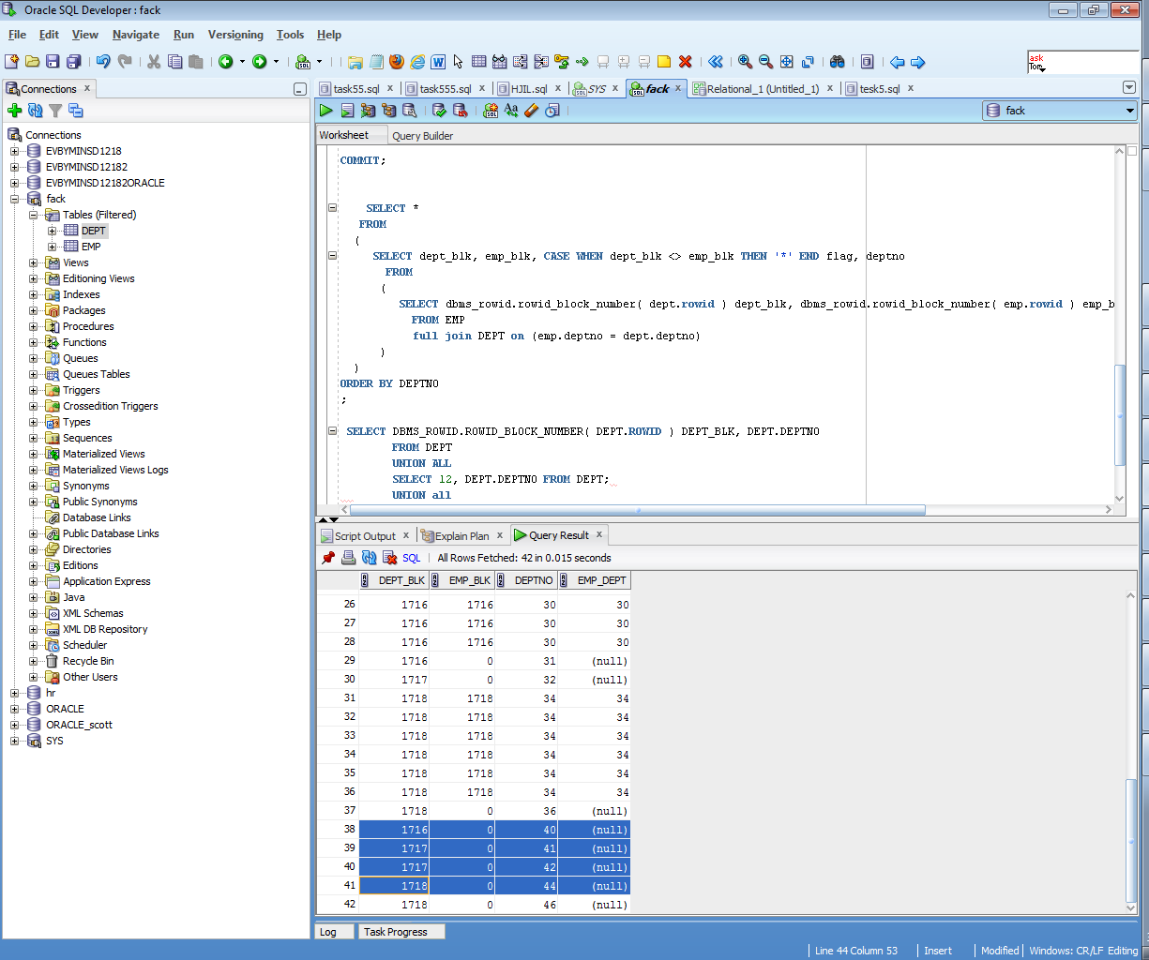

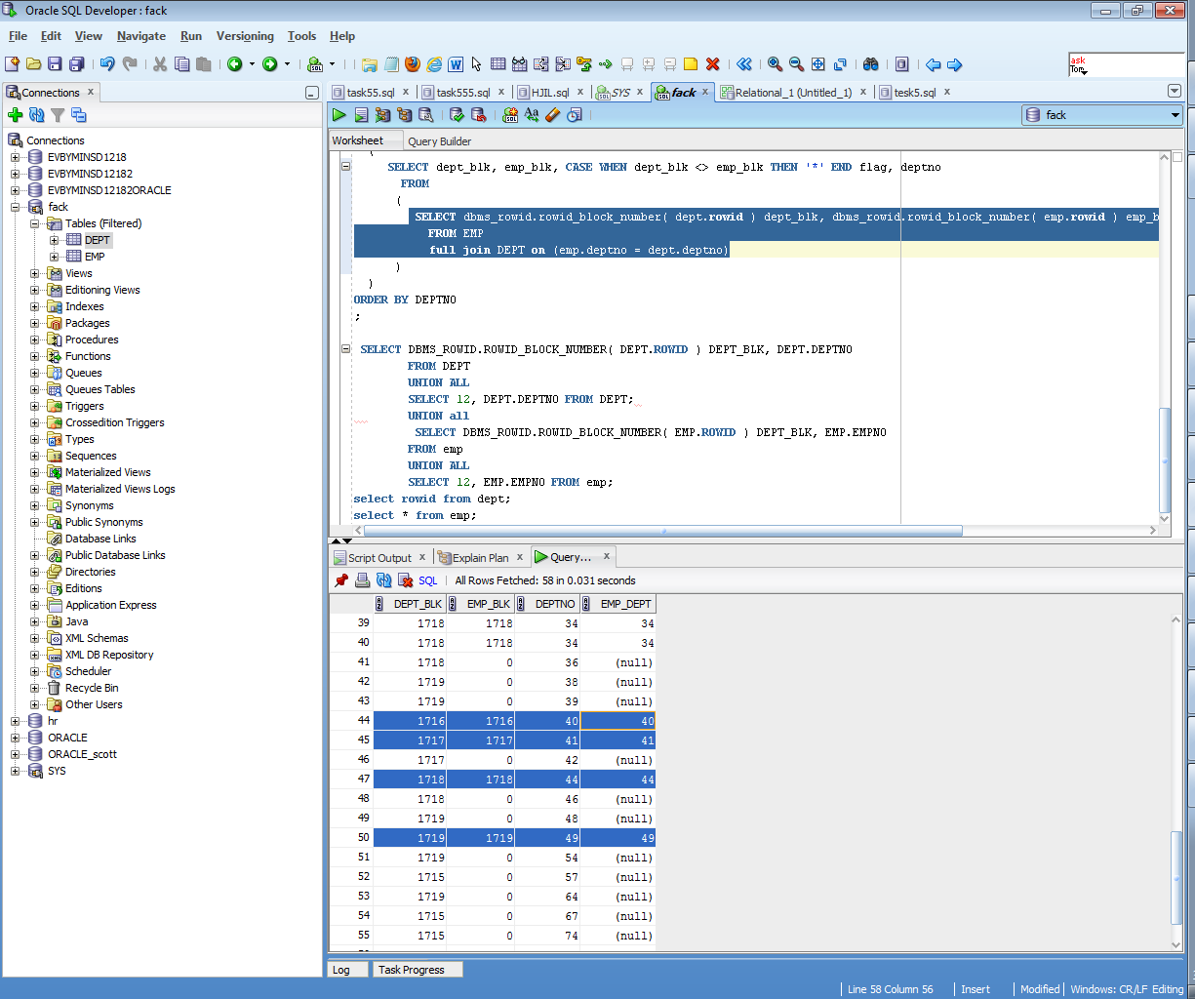

**5**

**In pictures we can see that data is located in the same blocks according the same value of hash key(and hash key unites PK’s of clustered tables)**

